Supplementary Material
Molecular and physiological characterization of sorbitol utilization by the probiotic Pediococcus parvulus 2.6
Pérez-Ramos A.¹, Werning, M.L.^{1,2}, Prieto A.¹, Russo P.³, Spano G.³, Mohedano M.L.¹, López P.^{1*}
¹Biological Research Center (CIB), CSIC, Madrid, Spain
²Center of Research and Transfer of Catamarca (CITCA), CONICET, Catamarca, Argentina

³Department of Agricultural, Food and Environmental Sciences, University of Foggia, Foggia, Italy
* Correspondence:
Dr. Paloma López
plg@cib.csic.es

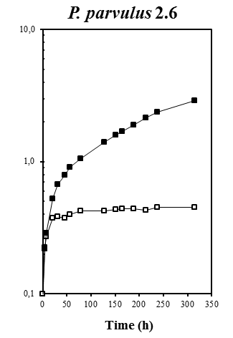
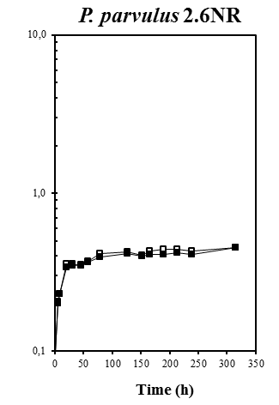
10.0
10.0
1.0
1.0
0.1
0.1
OD_{600nm}
OD_{600nm}

Figure S1. Influence of sorbitol in growth of P. parvulus 2.6 and 2.6NR. The bacteria were grown in either MRS (□) or MRSS (■) media.

Figure S2. Chromatograms of the rearrangement of pPP1 to generate pPP1*. DNA sequence was performed with the dideoxinucleotide method by using total plasmidic preparation of the indicated strains and the pPP1*F as substrates. * indicates mismatch between the two DNA sequences (A and B). The vertical arrows indicates nucleotides from which the two DNA sequences differ.

Table S1. Genes and ORF present in plasmid pPP1 of P. parvulus 2.6
Gene |  |  |  | Protein
Name | Start | Stop | Name | No of amino acids | Function
tnp | 50 | 433 | Tnp | 127 | Multispecie transposase
gutF | 808 | 1611 | GutF | 267 | Sorbitol-6-phospate dehydrogenase
gutR | 1645 | 3510 | GutR | 621 | Sorbitol operon transcriptional regulator
gutM | 3510 | 4016 | GutM | 168 | Sorbitol operon activator
gutC | 4021 | 4572 | GutC | 183 | Sorbitol PTS, EIIC component
gutB | 4596 | 5615 | GutB | 339 | Sorbitol PTS, EIIBC component
gutA | 5643 | 6020 | GutA | 125 | Sorbitol PTS, EIIA component
orf1 | 6815 | 7174 | ORF1 | 119 | Hypotetical protein
res | 7845 | 7258 | Res | 195 | PIN-related DNA recombinase/invertase
tauE | 9239 | 8397 | TauE | 280 | Putative permease, Sulfite exporter TauE/SafE
tetR | 9346 | 9930 | TetR | 194 | TetR family transcriptional regulator
Orf2 | 10422 | 10664 | ORF2 | 80 | Hypotetical protein
Orf3 | 10726 | 11043 | ORF3 | 105 | Hypotetical protein
Orf4 | 11460 | 11161 | ORF4 | 99 | Hypotetical protein

