HCPro-mediated transmission by aphids of purified virions does not require its silencing suppression function and correlates with its ability to coat cell microtubules in loss-of-function mutant studies

Francisco Javier del Toro^{a*}; Eva Mencíaª; Emmanuel Aguilarª, Francisco Tenlladoª, Tomas Canto^{a*}

ªDepartamento de Biología Medioambiental, Centro de Investigaciones Biológicas, CSIC. Madrid 28040, Spain

*Corresponding authors
E-mail addresses: fjdts@cib.csic.es; tomas.canto@cib.csic.es

ABSTRACT
Native and amino acid (aa) substitution mutants of HCPro from potato virus Y (PVY) were transiently expressed in Nicotiana benthamiana leaves. Properties of those HCPro variants with regard to silencing suppression activities, mediation of viral transmission by aphids, and subcellular localization dynamics, were determined. One mutant failed to suppress silencing in agropatch assays, but could efficiently mediate the transmission by aphids of purified virions. This mutant also retained the ability to translocate to microtubules (MTs) in stressed cells. By contrast, another single aa substitution mutant displayed native-like silencing suppression activity in agropatch assays, but could not mediate transmission of PVY virions by aphids, and could not relocate to MTs. Our data show that silencing suppression by HCPro is not required in the aphid-mediated transmission of purified virions. In addition, since the same single aa alteration compromised both, viral transmission and coating of MTs, those two properties could be functionally related.

1. Introduction
The non-structural viral protein HCPro (helper component protease; Carrington et al., 1989) is required for the non-persistent transmission by aphids of viruses in the genus Potyvirus (Govier and Kassanis, 1974). HCPro has been found physically associated to the VPg that covalently caps the 5´ end of the genomic RNA in a small fraction of purified virion particles (Torrance et al., 2006), but transmission by aphids from purified virion preparations does not occur (Govier and Kassanis, 1974), and from freshly made extracts from infected plants only for the first few minutes (Govier and kassanis, 1974). On the other hand, sequential membrane feeding experiments demonstrated that HCPro could already be in the aphid food canal for a short time before virions, and still mediate their successful transmission (Govier et a., 1977; Thornbury et al., 1985; Canto et al., 1995b; Goytia et al., 2007). Dispersal from infected plants to other plants through aphid vectors requires therefore both, virions and HCPro in transmission-competent form.
HCPro is a product of the posttranslational processing of a large viral polyprotein. It has multiple functions required in the viral infection cycle: it has cysteine protease activity at its C-terminus that acts in cis- to detach it from the rest of the polyprotein downstream (Carrington et al., 1989), while at its N-terminus it is released by the protease activity of the P1 protein situated upstream (Carrington et al., 1988; García et al., 1989). HCPro is required for the horizontal dispersal of potyviruses by aphids, hence its original name, HC (Helper Component; Govier and Kassanis, 1974), which loss-of-function mutant studies have mapped to the N-terminus of the protein, specifically to particular amino acids (aas) and amino acidic motifs highly conserved among potyviruses, such as a KITC sequence, and others (Atreya et al., 1992; Dolja et al., 1993; Huet et al., 1994; Canto et al., 1995b; Llave et al., 1999a, 2002), and also to a PTK domain in its C-terminus region (Huet et al., 1994; Peng et al., 1998). HCPro has also silencing suppression function, hence its being a pathogenicity determinant in potyviral infections (Anandalakhsmi et al., 1998), which maps to the central protein domain (Shiboleth et al., 2007) as does its binding to lRNAs in vitro (Urcuqui-Inchima et al., 1999). Silencing suppression correlates with the ability of HCPro to bind to small RNAs (sRNAs) (García-Ruíz et al., 2015) with a preference for those of 21 nt of viral sequence and with 5´-end adenines (del Toro et al., 2017), and possibly also with its interference with chemical sRNA modifications required for their stabilization and loading into RNA-induced slicing complexes (Ebhart et al., 2005; Jamous et al., 2011; Ivanov et al., 2015). HCPro has also been reported to interact in vivo in transient overexpression experiments with several host factors, such as a ribosomal component within RNA-containing granular structures (Hafrén et al., 2015), microtubule-associated proteins, translation initiation factors, proteasome factors, and has other properties as well (for review, see Valli, 2017).
Transmission-functional forms of HCPro appear to be soluble homodimers (Thornbury et al., 1985; Ruíz-Ferrer et al., 2005). In this regard, in Nicotiana benthamiana epidermal cells fluorescent potato virus Y (PVY) HCPro dimers were found to distribute evenly in the cytoplasm and also forming part of both, large and small irregular cytoplasmic inclusions. Fluorescence could also be found associated to specific subcellular structures, such as regular nodes anchored to the cortical endoplasmic reticulum (ER), or the entire microtubule (MT) cytoskeleton, where it accumulated in response to some stresses (del Toro et al., 2014).
With regard to its transmission function, molecular studies have shown that HCPro can interact on the one hand with the N-terminal end of the viral coat protein (CP), which in virions protrudes outwards and is exposed to molecular interactions, and where a conserved DAG motif was required for CP binding with HCPro and aphid-mediated transmission of virions (Harrison and Robinson, 1988; Atreya et al., 1990, 1991; Baulcombe et al., 1993; Blanc et al., 1998; Peng et al., 1998; López-Moya et al., 1999; Seo et al., 2010). On the insect side, interactions of HCPro with specific insect factors have been proposed, but this has yet to be fully confirmed (Uzest et al., 2007; Fernández-Calvino et al., 2010). Microscopy data have shown that HCPro targets indeed a specific, small distal region inside the aphid stylet (Ammar et al., 1994; Uzest et al., 2010). Viruliferous insects transmit viruses when feeding into recipient plants, being the number of particles actually infecting a plant in a single feeding event very low (Martín et al., 1997; Powel, 2005; Will et al., 2007, Moury et al., 2007). The cumulative experimental data support the so-called “bridge hypothesis” in which HCPro interacts on the one hand with virions and on the other with aphid receptors, although how this binding to and release from the aphid stylet occurs in the transmission process is not yet understood.
There is a need for information on how the subcellular distribution and molecular properties of virions and transmission-competent forms of HCPro are affected in donor cells when aphids alter their subcellular structures and osmotic integrities when probing them, and whether this could influence the transmission process. Also on how virions released from the insect do establish infection in recipient plants. To our knowledge it has not been confirmed either whether the silencing suppression function of HCPro could be required at any step of the transmission process. In this study we have used native and function-deficient substitution mutants of HCPro that we could successfully purify, and also sets of biological tests that have allowed us to show that a suppression-deficient mutant of HCPro could mediate the transmission by aphids of purified virions. We also show that a substitution in a single aa located in the N-terminal region of HCPro abolished both, mediation of viral transmission and ability to coat MTs.

2. Materials and Methods
2.1. Plants and viruses
Only Nicotiana benthamiana plants were used in this study. A transmission-competent Scottish isolate from PVY was used in aphid transmission assays (isolate PVY^{O}-SCRI-O, Barker et al., 2009; genbank accession number of the full-length sequence AJ585196), and from this isolate the P1HCPro bi-cistron sequence found in the binary constructs used in this work originated. This virus isolate was been maintained in N. benthamiana plants for over 14 years through either mechanical inoculation or aphid transmission passages.
2.2. Binary constructs used for the transient expression of HCPro variants by agroinfiltration
Several pROK2-based binary vectors were used in this work that expressed native or mutant forms of PVY HCPro fused to different tags: a vector encoding a modified P1-6x-HCPro bi-cistron that expresses a P1 protein that detaches itself after translation from an HCPro tagged with a serine+six histidines at its N-terminus that is functional in both, suppression of silencing and mediation of viral transmission by aphids (construct P1-6x-HCPro; Tena et al., 2013); a substitution mutant vector expressing the P1-6x-HCPro bi-cistron in which two consecutive aas in the central domain of HCPro (Asn, Leu) had been replaced by two alanines, resulting in a suppression of silencing-deficient protein (construct P1-6x-HCPro mutB; del Toro et al., 2017); and a substitution mutant vector expressing a P1-6x-HCPro bi-cistron in which a single lysine aa in the N-terminal domain of HCPro had been replaced by an asparagine (AAG to AAT, construct P1-6x-HCPro mutD). This particular substitution had been attributed to be the cause of the lack of aphid transmissibility of a naturally-occurring isolate of PVY (Canto et al., 1995b). To generate this latter construct P1-6x-HCPro mutD, the P1-6x-HCPro region up to nt 152 of the HCPro sequence was amplified by PCR from construct P1-6x-HCPro with PhusionTM DNA polymerase (Finnzymes, Waltham, MA, USA) that leaves blunt-ended fragments, using a forward primer containing the start of the P1 sequence and a reverse primer 5´-ATATTGTAGCACGGGAGGATAC-3´ containing the nucleotide substitution CTT to ATT (highlighted) responsible for the aa mutation (AAG to AAT in the forward sequence). The region downstream in the HCPro sequence was also amplified by PCR using a forward primer 5´-ATGGTTAACCTGCCCCACCTGTGC-3´ with an engineered HpaI site (highlighted). After digestion of this second fragment with HpaI, it was ligated to the first PCR fragment, and the ligation was used as template to amplify a fusion PCR fragment that contained the desired mutation. The fusion PCR fragment was then cloned into construct P1-6x-HCPro using restriction enzymes ApaL1 and XhoI, which have unique restriction sites in the vector. The nucleotide and aa substitutions in the HCPro sequences of constructs P1-6x-HCPro mutB and P1-6x-HCPro mutD are schematically shown in Fig. 1A.
For the detection of fluorescence derived from HCPro dimers using bimolecular fluorescence complementation (BiFC), additional binary vectors were used expressing the native or the two mutant forms of HCPro as fusions to split N- or C- parts of the monomeric red fluorescent protein1 (mRFP1): constructs sRN-6x-HCPro and sRC-6x-HCPro, which expressed fusionsto the native HCPro (del Toro et al., 2014); constructs sRN-6x-HCPro mutB and sRC-6x-HCPro mutB; and constructs sRN-6x-HCPro mutD and sRC-6x-HCPro mutD, which expressed fusions to the HCPro mutB or HCPro mutD mutants, respectively. To generate constructs sRN-6x-HCPro mutB and sRC-6x-HCPro mutB the HCPro sequence was amplified by PCR from construct P1-6x-HCPro mutB using appropriate primers, and cloned into constructs sRN-6x-HCPro and sRC-6x-HCPro digested with XhoI and KpnI, which have unique restriction sites in that vector. To generate constructs sRN-6x-HCPro mutD and sRC-6x-HCPro mutD, a PCR fragment was amplified from constructs sRN or sRC-6x-HCPro using PhusionTM polymerase, an appropriate forward primer and a reverse primer 5´-ATATTGTAGCACGGGAGGATAC-3´ that contains the nucleotide substitution CTT to ATT of the mutation highlighted (AAG to AAT in the forward sequence). The region downstream in the HCPro sequence was also amplified by PCR using a forward primer 5´-ATGGTTAACCTGCCCCACCTGTGC-3´ with an engineered HpaI site highlighted. The following steps to obtain fusion PCR fragments were similar to those followed to obtain construct P1-6x-HCPro mutD (see above). The fusion PCR fragments obtained were then inserted into constructs sRN- or sRC-6x-HCPro linearized with BamH1 and Xho1 with unique sites to generate the final two constructs.
2.3. Transient expression by agroinfiltration, and suppression of silencing in agropatch assays
The different HCPro variants used in this work where transiently expressed in fully expanded leaves of N. benthamiana using the agroinfiltration technique as described (Canto et al., 2002). Briefly, agrobacterium cultures carrying binary constructs where grown exponentially at 28 °C under the appropriate antibiotic selection (kanamycin resistance provided by the pROK2-based vectors, and rifampicin), pelleted, and resuspended to an optical density at 600 nm of 0.3 in 2-N-morpholino ethanesulfonic acid (MES)-based infiltration buffer containing acetosyringone 0.2 mM to activate T-DNA transfer. Bacterial solutions were infiltrated either alone or in mixed solutions if co-expression of more than one construct was sought, using needle-less syringes. In the case of HCPro constructs, at 4 to 5 days after infiltration the highest steady-state levels of protein were obtained under our experimental conditions, and at this time post-infiltration samples were collected or assessed.
For silencing suppression assays, separate patches in the same leaf were agroinfiltrated with a GFP-expressing vector as reporter (González et al., 2010) together with either HCPro-expressing binary vectors or the empty vector (pROK2). The partial silencing of the GFP reporter by the plant defenses is alleviated by the presence of active suppressors and the strength of suppression could be assessed by measuring the increase on steady-state levels of GFP in infiltrated patches by western blotting, and/or by the relative levels of GFP-derived fluorescence when illuminated with a UV lamp (Black Ray long wave UV lamp; UVP).
2.4 . HCPro purification and quantification
Native and mutant forms of histidine-tagged HCPro were purified under non-denaturing conditions using Ni-NTA agarose (Qiagen) as described (del Toro et al., 2017) with the only difference that the starting plant material was not virus-infected systemic tissue, but fully expanded leaves agroinfiltrated with the corresponding binary vectors and collected at three days post-infiltration (~100 g of agroinfiltrated plant material was used for each purification).
Transiently-expressed proteins (HCPro variants and GFP) or purified HCPro preparations were fractionated in denaturing SDS-PAGE gels (10% acrylamide gels for HCPro, 15 % for GFP). Resolved proteins in polyacrylamide gels were either stained with coomasie blue, or wet-transferred (western blot) to PVDF membranes (Amersham-GE Healthcare) as described (del Toro et al., 2017). To detect the HCPro band in those membranes, a specific mouse monoclonal antibody was used (1A11, Canto et al., 1995a). To detect the GFP band, a polyclonal rabbit antiserum donated by G. Cowan (The James Hutton Institute, Dundee, U.K.) was used. Commercial alkaline phosphatase-linked secondary antibodies and SigmaFastTM BCIP/NBT substrate tablets were also used (SIGMA Aldrich). Relative band densities in scanned images from stained gels or from western blot membranes were quantified with Image J software (v. 1.48; www.imagej.nih.gov).
2.5. Viral transmission assays
In order to test the abilities of native and mutant HCPro variants to mediate viral transmission by aphids, purified PVY virions and histidine-tagged native and mutant forms of HCPro, purified under non-denaturing conditions were used in artificial membrane feeding experiments. Purification of HCPro variants transiently expressed in agroinfiltrated tissue has been described above. However, in order to be used in aphid transmission experiments the presence of 0.5 M NaCl and of 0.4 M EGTA in the elution buffer of purified HCPro preparations had to be removed in an additional step, using AmiconTM ultra 0.5 ml 10K regenerated cellulose centrifugal filter units (Millipore, Whitehouse Station, NJ, USA), following the manufacturer instructions for buffer exchange in order to leave them in TSM buffer (0.1 M Tris, 20 mM MgSO₄, 20% sucrose, pH 7.2). Purification of PVY virions from systemically infected plant tissue was performed following the protocol described in Murphy et al., (1990), but omitting the last CsSO₄ cushion step.
Artificial membrane feeding of the peach aphid Myzus persicae on mixtures of purified virions and HCPro preparations were performed as described (Canto et al., 1995b). Briefly, aphids were collected in glass bottles in groups of 50 and starved for 3 hours before allowing the group to feed through stretched parafilm membranes (Bemis, Neenah, WI, USA) on 50 µl TSM feeding solutions containing ~ 2 µg of viral CP and ~ 0.5 to 1 µg of HCPro (estimated by densitometry measure against standards of CP or HCPro bands in coomasie blue-stained SDS-PAGE gels). Aphids were allowed after starvation to feed through membranes for 10-15 minutes before being then transferred to recipient plantlets (10 aphids/plant) with the help of a fine paint brush, where they were allowed to stay overnight before being killed with insecticide. Infection symptoms in recipient plantlets were assessed visually two weeks after the experiment, as they were very characteristic, with severe stunting (as shown in Fig. 4B) and intense chlorosis. Plants with atypical appearance were tested for infection by western blot using a polyclonal antibody to the viral CP (Llave et al., 1999b).
2.6. Visualization of the subcellular dynamics of HCPro dimers in epidermal cells
Imaging and recording of fluorescence derived from the BiFC of the sRN- and sRC-tagged native or mutant HCPro constructs was conducted as described (del Toro et al., 2014), using a Leica SP2 confocal laser-scanning microscope and software (Leica Microsystems, Wetzlar, Germany), in epidermal cells of agroinfiltrated tissue at 4-5 dpi, with a ×40 magnification oil immersion objective ± additional digital zooming. Excitation and emission settings were 561 nm, and 575 to 640 nm, respectively.
Leaf tissue samples for confocal viewing were mounted fresh on microscopy slides, and viewed either untreated or exposed to a stressing emulsion of 30% ethyl acetate plus 20% isopropanol, in water. To do that, leaf tissue was infiltrated with the emulsion 20 minutes before confocal viewing. Epidermal cells directly exposed to the stress became damaged and plasmolyzed, but cells in tissue adjacent to the damaged area appeared intact and turgent, although exposed to a degree of osmotic stress. In that region of adjacent cells the translocation of HCPro towards MTs could be observed and was recorded.
2.7. Treatment with microtubule-disrupting agents and its effect on the subcellular dynamics of HCPro and on the transmission of virus by aphids
In a set of experiments, the subcellular distribution of HCPro dimers was also analyzed in epidermal cells of leaf tissue infiltrated with the sRN- and sRC-tagged native 6x-HCPro that were treated with the MT disrupting agents colchicine (500 µM in water) or oryzalin [20 µg/ml (57 µM) in water with 0.08% ethanol] for three hours before confocal viewing, and in the presence or absence of an ulterior treatment with a stressing agent (30% ethyl acetate plus 20% isopropanol, in water) 20 minutes before confocal viewing as already described above.
Experiments were also carried out to study the effect of MT-disrupting agents on viral transmission by aphids. For this purpose, donor PVY-infected leaf tissues were either infiltrated with 0.08% ethanol in water as control, or with a solution of colchicine (500 µM) plus oryzalin [20 µg/ml (57 µM)], in water with 0.08% ethanol, three hours before use as donor tissue in aphid transmission assays. As additional control, these concentrations of MT-disrupting agents were also added to solutions of purified virions and HCPro preparations used in aphid membrane feeding experiments. After 3-hour starvation insects were allowed to feed for 10-15 minutes on the infected leaf tissues or in solutions of purified virions plus HCPro preparation through membranes, treated or untreated with MT-disrupting agents, before being transferred to recipient plantlets with the help of a fine paint brush, where they were allowed to stay overnight before being killed with insecticide as described (del Toro et al., 2014).
2.8. Assessment of 21 nt sRNA sequences that could match those of the PVY genome in N. benthamiana plants
Predicted sequences of 21 nt-length that if transcribed could match either completely, or with one or two mistmatches those of our PVY genome, were searched for in genome and transcriptome databases of N. benthamiana (http://sydney.edu.au/), using Bowtie (Langmead et al., 2009) and different perl scripts developed in the laboratory. We also searched actual next generation sequencing (NGS) reads derived from a sRNA library obtained from N. benthamiana plants infected with the potexvirus potato virus X (PVX) (del Toro et al., 2017; whose high-throughput sequencing data are uploaded into the Gene Expression Omnibus (GEO, http://www.ncbi.nlm.nih.gov/geo) with accession number GSE71921.
3. Results
3.1. Different silencing suppression activities and accumulation levels of native and mutant HCPro variants expressed in agropatch assays
We expressed native HCPro tagged at its N-terminus with six histidines (6x-HCPro) or three aa substitution variants affecting motifs in the central domain of the protein that had their silencing suppression activities abolished (HCPro mutants A, B, and C; Tena et al., 2013; del Toro et al., 2017) in N. benthamiana leaves to attempt to purify them for use in membrane transmission assays. However, two of the mutants (A and C) repeatedly failed to accumulate transiently in agroinfiltrated patches (del Toro et al., 2017) even when co-expressed with other suppressors (data not shown), suggesting that in those mutants protein stability was also affected negatively. Therefore, we used constructs harboring the native HCPro and the more stable mutant B (P1-6x-HCPro, and P1-6x-HCPro mutB, respectively) plus a new mutant with a single substitution in aa 50 (Lys to Asn) in the N-terminal domain of HCPro (construc P1-6x-HCPro mutD), which had been associated to the lack of aphid transmissibility in a PVY isolate generated through serial mechanical passages in the laboratory (Canto et al., 1995a) and of unknown suppressor of silencing activity. The three HCPro variants are schematically represented in Fig. 1A and where expressed from binary vectors as part of a P1-6x-HCPro polycistron, from which the three HCPros detached from the P1 protein upstream after translation (6x-HCPro; 6x-HCPro mutB; and 6x-HCPro mutD; Fig. 1A). When these constructs were co-expressed with a binary construct encoding a GFP reporter, the partial silencing of the reporter was similarly suppressed in the cases of constructs P1-6x-HCPro and P1-6x-HCPro mutD, but not in the case of construct P1-6x-HCPro mutB (Figs. 1B and 1C, lower GFP western blot panel). Transient accumulation of 6x-HCPro mutB was lower than those of 6x-HCPro or 6x-HCPro mutD, while steady-state levels of accumulation of 6x-HCPro mutD were higher than those of 6x-HCPro, suggesting that the latter may be more stable than the native protein (Fig. 1C, upper western blot panel).
3.2. Different abilities of native and mutant HCPro variants to mediate the transmission of PVY by aphids
To test the abilities of variants 6x-HCPro, 6x-HCPro mutB and 6x-HCPro mutD to mediate the transmission of PVY by aphids, these proteins were purified under non-denaturing conditions from infiltared patches, dialyzed and quantified (Fig. 2A). Those HCPro fractions were used in membrane aphid feeding experiments, mixed with purified PVY virions in separate independent experiments. We found that both, native and 6x-HCPro mutB fractions were able to mediate the transmission of purified virions, whereas 6x-HCPro mutD failed to mediate any single transmission at all (Fig. 2B).
3.3. Different abilities of native and mutant HCPro variants to coat the microtubule cytoskeleton in stressed epidermal cells
Split mRFP-tagged homodimers of native or mutant forms of HCPro were expressed transiently in N. benthamiana epidermal cells by agroinfiltration (Fig. 3A) and the BiFC-derived fluorescence from homodimers was detected by confocal microscopy, in cells from untreated tissues, or in cells from tissues treated with stressing agents: in untreated epidermal cells, BiFC fluorescence was found to be mainly cytosolic, with the presence in some cells of numerous small irregular inclusions, and sometimes of one or two larger inclusions (Fig. 3B, panels in upper row). By contrast, in stressed cells BiFC-derived fluorescence in the case of the native HCPro almost completely redistributed in some cells from cytosol to filamentous structures that we had previously shown to be MTs, (del Toro et al., 2014), entirely coating this cellular cytoskeleton (Figs. 3B and 3C, left panels). This redistribution to MTs was also observed in the case of the mutant variant HCPro mutB (Fig. 3B, central panel), but in the case of HCPro mutD it was not observed (Figs. 3B and 3C, right panels).
3.4. Extensive microtubule disruption does not affect viral transmission by aphids
We had previously shown that local treatment of leaf tissue in MT-fluorescent transgenic tobacco plants (Tua-GFP; Gillespie et al., 2002) with colchicine 0.5 µM at three to five days before confocal viewing resulted in the complete disorganization of the fluorescent transgenic MT cytoskeleton in epidermal cells, and that an equivalent treatment on virus-infected N. benthamiana leaves failed to prevent the transmission of the virus by aphids (del Toro et al., 2014). However, the 3-5 day time interval between treatment and transmission assay was long, and there are claims that the complete disruption of MT fluorescent filaments in Tua-GFP plants by colchicine treatment (Gillespie et al., 2002) does not occur in MTs of non-transgenic plants under the same treatment (Seemanpillai et al., 2006). We took advantage of the fact that BiFC HCPro dimer constructs completely coat the MT cytoskeleton in stressed N. benthamiana cells to test the effect of MT-disrupting agents on this fluorescence coating, as it would be informative of the integrity of the MT cytoskeleton: when tissues were treated with either oryzalin or colchicine three hours before viewing, only traces of HCPro BiFC-derived fluorescent filaments could be observed in stressed cells, indicating that the MT cytoskeleton of N. benthamiana epidermal cells had been disorganized for the most part, but not completely (Fig. 4A, arrows), under the conditions of the experiment. However, treatment at those concentrations with oryzalin and colchicine combined failed to significantly affect aphid transmission of PVY from either virus-infected leaves or from purified virion and HCPro preparations in membrane assays (Fig. 4B).
4. Discussion
To spread infection through aphids, molecular events may be required not only for aphids to actually carry the virus, but also during the acquisition phase in which insects must take both virus and HCPro from donor cells through probing and feeding, and in the phase of delivery and establishment of infection in recipient cells. We have used native as well as loss-of-function aa substitution mutants of HCPro to further investigate its role in these phases. We have characterized those variants with regard to their mediation of viral transmission by aphids, gene silencing suppression activities, and subcellular localization properties. Results are summarized in Table 1.
To our knowledge it had not yet been shown whether HCPro suppression of silencing function was required at any phase in the transmission process, for several reasons: potyvirus mutants that have their suppression function compromised either fail to infect compatible hosts or systemic infections have such low viral titers that this alone causes transmission assays to fail (Atreya et al., 1992; Kasschau and Carrington, 2001; González-Jara et al., 2005). In addition, HCPro purification from plant tissues infected by those mutants was either difficult or impossible to achieve, preventing their use in membrane assays. At the time when some of those mutants where characterized, the suppression of silencing function of HCPro and assays to estimate its strength were not yet established (Atreya et al., 1992, 1995; Huet et al., 1994; Peng et al., 1998). We have made here an HCPro mutant that is suppression of silencing deficient (Fig. 1, HCPro mutB), which could nevertheless accumulate transiently in agroinfiltrated tissue in sufficient amounts to be purified. Using membrane feeding experiments we could show that this mutant can mediate the transmission by aphids of purified virions (Fig. 3). This result demonstrates that silencing suppression by HCPro is dispensable for the transmission of purified virion solutions. Although in purified virion preparations there is an HCPro molecule bound to the VPg in a small number of virions (Torrance et al., 2006) that is not mutated, it is unlikely that it would provide any suppressor function: our protocol for virion purification involves denaturing steps, such as a 40% chloroform extraction, and any activity left would also be constrained by its being physically bound to the viral Vpg at the proximal end of the virion particle.
Why would the transmission process require silencing suppression function when it is not required in mechanical inoculations of virions? Transmission of potyviruses by aphids involves a very small number of particles (average of 0.5-3.2 particles/single transmission event in the case of PVY; Moury et al., 2007), and it is possible that to establish a successful infection in the recipient cell the viral RNA released from the insect could require protection from the start against silencing. Such low numbers of virus particles involved in an infection could be the result of a limiting number of binding sites in the aphid stylets as suggested (Moury et al., 2007), but antiviral silencing activity in the recipient cell might contribute too. We checked the N. benthamiana genome for potential 21 nt sequences that would match those in the PVY genome and found full 30 matches, 3 of them in the transcriptome. However, when we analyzed an actual population of 21 nt sRNAs sequenced from N. benthamiana plants that were not infected by PVY, we found that none matched the PVY genome even allowing for two mismatches/sRNA (Table 2). Therefore, PVY virions released into recipient cells of healthy plants by viruliferous aphids are not expected to encounter siRNAs to its genomic sequence. However, sRNAs of viral sequence ingested by the aphid together with virions from infected donors could also be transferred to recipient cells. Thus, our observation that the suppression of silencing function of HCPro is dispensable in the transmission of purified virions may not be extrapolable to natural transmissions.
Of the many molecular aspects in the transmission process that have been characterized a relevant one is the required interaction of HCPro with the viral CP (Atreya et al., 1990, 1991, 1995; Baulcombe et al., 1993; Pirone and Blanc, 1996; Blanc et al., 1997; Seo et al., 2010). As mentioned before, there is also evidence of HCPro being bound to the VPg protein in a small proportion of purified particles, and this interaction has also been proposed to have a role in transmission (Torrance et al., 2006). However, purified virions are not transmissible by themselves, perhaps because the stringent purification conditions have inactivated the VPg-bound HCPro and/or prevented the interaction of HCPro with the virion CPs to establish or remain. In any event, any role of HCPro-VPg in transmission would have to be complementary to the one mediated by the HCPro-CP interaction, as the already mentioned literature demonstrating the need for the latter is compelling.
How do interactions between HCPro and virion CPs take place? Do they already occur in intact cells or are they triggered during the first phase of transmission and where? Although virions of potyviruses distribute throughout the cytosol, as does HCPro, to our knowledge there is no evidence that in intact cells HCPro coats virions (Roudet-Tavert et al., 2002). It is likely that in natural transmissions the interactions between HCPro and virion CPs would occur during the first phase of transmission as donor cells become disturbed, possibly in response to chemical or osmotic changes caused by probing and ulterior feeding by aphids. In this regard, we know that fluorescence from tagged PVY HCPro BiFC dimers could alter its subcellular distribution in response to a cellular stress and relocate to the MT cytoskeleton (del Toro et al., 2014, and Fig. 2) or to its remnants, if it became disrupted by colchicine treatment (del Toro et al., 2014, and Fig. 4). Thus, HCPro can interact de novo with specific MT-related components in response to changes in the cellular environment. Interactions de novo in response to alterations in the subcellular environment could then also happen with other components, such as virions. We present here evidence that a single aa substitution at the N-terminus of HCPro abolishes both, its transmission competence and its ability to coat MTs (Fig. 3). Both properties thus map to the same domain of the protein, and leave open the possibility that they might be functionally related. It has been reported that HCPro from several potyviruses can interact with an MT-associated host protein (Haikonen et al., 2013a), but that interaction is affected by aa alterations in the C-terminal region of HCPro, and requires the overexpression of the host factor to be visualized by BiFC (Haikonen et al., 2013b). Therefore the relocalization of PVY HCPro BiFC-derived fluorescence to the whole MT cytoskeleton in the absence of an overexpressed host factor appears to be mediated by a different mechanism.
Viruses from the genus Caulimovirus require the concourse of a helper non-structural viral protein to be transmitted by vectors. Interestingly, there is evidence that aphid probing triggers the redistribution throughout the cell of caulimovirus virions from electron-dense inclusion bodies (viral factories) as well as that of the helper protein P2 from a single inclusion body, using both of them the MT cytoskeleton, where they interact with each other, in order to maximize the efficiency of transmission (Bak et al., 2012). Indeed, MT disruption significantly reduced caulimovirus transmission by the aphid vector (Martiniére et al., 2009, 2013). While MT-coating by HCPro in response to a cellular stress has parallelisms with properties of the caulimoviral protein P2, differences are also important: potyviruses are not known to accumulate in viroplasms or in specific subcellular structures from where they would need to redistribute to maximize transmission. We could not induce HCPro coating of MTs by overnight aphid feeding on leaf patches (not shown), and substantial MT disruption did not affect transmission under our experimental conditions (Fig. 4). Our data indicate that if relocation of HCPro to the MT cytoskeleton was necessary for the transmission process, the actual integrity of the MT cytoskeleton would still be dispensable. However, this may not be that surprising, since different to caulimoviruses, PVY virions and HCPro may not need to redistribute from specific single bodies throughout the cell using an intact MT cytoskeleton, as they are already ubiquitous. The MT or its remnants could still act as scaffolds where the interactions between HCPro and virion CPs required for transmission are chaperoned in response to aphid probing.

Acknowledgenments
Funding: This work was supported by the Spanish Ministry of Economy and Competitiveness [Grant Refs. BIO2013-47940-R and BIO2016-75619-R, (AEI/FEDER, EU)].

Figure Legends
Figure 1. A, schematic representation of binary vectors carrying modified P1HCPro bi-cistrons used to express transiently by agroinfiltration 6x histidine-tagged native HCPro (construct P1-6x-HCPro) or two amino acid (aa) substitution mutant forms (constructs P1-6x-HCPro mutB and P1-6x-HCPro mutD). Specific aa substitutions in the mutants are indicated. The viral P1 protease cistron immediately upstream the HCPro sequence in the potyviral sequence is indicated; 6x indicates a sequence encoding for a serine+6x-histidine tag inserted between P1 and HCPro that remains fused to the latter after self-cleavage of P1 protease activity at its recognition motif upstream the 6x motif. B, visualization under the UV lamp of fluorescence derived from a green fluorescent protein (GFP) reporter expressed from a binary vector in agroinfiltrated leaf patches of Nicotiana benthamiana, together with the empty vector pROK2 or with pROK2 vectors expressing P1-6x-HCPro; P1-6x-HCPro mutB; or P1-6x-HCPro mutD. C, detection by western blot of the steady-state levels of the HCPro variants and of the GFP reporter transiently expressed in the infiltrated patches shown in A using specific antibodies (upper and third panel from the top, respectively). The HCPro band migrates below the 50 kDa band of the protein marker (M), just above a contaminant band from a host protein also recognized by the antibody. Lane labeled H contains non-infiltrated healthy plant sample. The second and fourth panels show rubisco bands in the corresponding membranes stained with Ponceau redTM previous to antibody labeling as controls of loading.
Figure 2. Transmission by aphids from solutions of purified PVY virions and HCPro. Groups of 50 aphids were allowed to feed after three-hour starvation on 50 µl solutions containing purified HCPro (~1 µg) and purified virions (~2 µg of viral coat protein) through membranes for 15 minutes before being transferred individually to recipient plantlets. In all experiments, each plantlet received 10 aphids. A, examples of samples of 6x-HCPro; 6x-HCPro mutB; or 6x-HCPro mutD purified under non-denaturing conditions and dialyzed to remove salts and chelating agents used in transmission tests. B, three independent transmission experiments performed to assess the abilities of HCPro variants to mediate transmission. HCPro mutB could mediate transmission whereas HCPro mutD could not.
Figure 3. A, detection by western blot of the accumulation in agroinfiltrated patches of the HCPro forms tagged with the N- or C- split parts of the monomeric red fluorescent protein (smRFP) when expressed separately or combined, using antibodies specific to HCPro. The steady-state levels of accumulation of the HCPro mutD dimer forms were higher than those of the native protein, and both were higher than those of HCPro mutB, which lacked suppressor activities and were thus silenced efficiently by the plant defenses to T-DNA transcripts. Lanes labeled H and M correspond to a non-infiltrated healthy plant sample and to protein markers, respectively. The lower panels show the rubisco protein bands in the corresponding membranes, stained with Ponceau redTM as controls of loading. B, visualization in Nicotiana benthamiana epidermal cell fileds of the fluorescence derived from the bimolecular fluorescence complementation (BiFC) of HCPro homodimers (native, mutant B or mutant D variants) tagged with smRFP parts, co-expressed transiently by agroinfiltration (left, central and right panels, respectively). Infiltrated patches were either left untreated prior to confocal viewing, or exposed to an emulsion of 30% ethyl acetate and 20% isopropanol in water to induce osmotic stress in epidermal cell fields adjacent to the treated areas. Distribution of fluorescence in non-stressed vs. stressed cells is shown in the upper vs. lower rows of epidermal cell panels, respectively. In untreated areas, fluorescence distributed throughout the cytosol and as inclusions. In stressed cells, fluorescence relocated mainly to the microtubules (MT) and appeared as filaments, in the cases of native HCPro and HCPro mutB forms, but not in the case of HCPro mutD. C, close-up view in treated single epidermal cells of BiFC fluorescence derived from native HCPro or from HCPro mutD dimers (left and right panels, respectively). Coating of MTs is apparent in the left panel, but was absent in the right panel. Size bars of 100 µm appear at the bottom left corner of panels in B and C.
Figure 4. Effects of treatment with microtubule (MT)-disrupting agents. A, on the coating of the MT cytoskeleton in epidermal cells of Nicotiana benthamiana with fluorescence derived from the bimolecular fluorescence complementation (BiFC) of native HCPro dimers tagged with the N- and C- split regions of monomeric red fluorescent protein (smRFP), co-expressed transiently by agroinfiltration. Three hours before viewing infiltrated patches were either left untreated (left-side panels) or treated with solutions containing 500 µm colchicine or 57 µM oryzalin (upper and lower right-side panels, respectively). Twenty minutes before confocal viewing all patches were exposed to a stressing agent to induce translocation of BiFC fluorescence from HCPro dimers to the MT cytoskeleton. Fluorescence in filamentous shapes was greatly reduced in the patches that had been treated with MT-disrupting agents (right vs. left panels) but still detectable (pointing arrows in right panels). Size bar of 100 µm appears at the bottom left corner. B, on the transmission of PVY by aphids from infected plants after treatment of donor tissue with microtubule (MT)-disrupting agents. Three hours before the transmission assay, infected donor leaves were infiltrated with a solution containing both, colchicine (500 µm) and oryzalin (57 µM) in water with 0.08% ethanol, or as a control with 0.08% ethanol in water. Aphids were allowed to feed on infiltrated tissue for 15 minutes before being transferred to recipient plantlets. In addition, to rule out that colchicine and oryzalin could affect negatively insect feeding behaviour, another set of aphids were fed through parafilm membranes for 15 minutes on solution of purified 6x-HCPro and virions with colchicine (500 µm) and oryzalin (57 µM), before being transferred to recipient plantlets. In all cases, each plantlet received 10 aphids. In the three cases tested transmission was successful, and differences in transmission rates (shown in the figure as the number of plants that became infected/the total) were not significant (Fisher´s exact test, P<0.05).

Figure 1
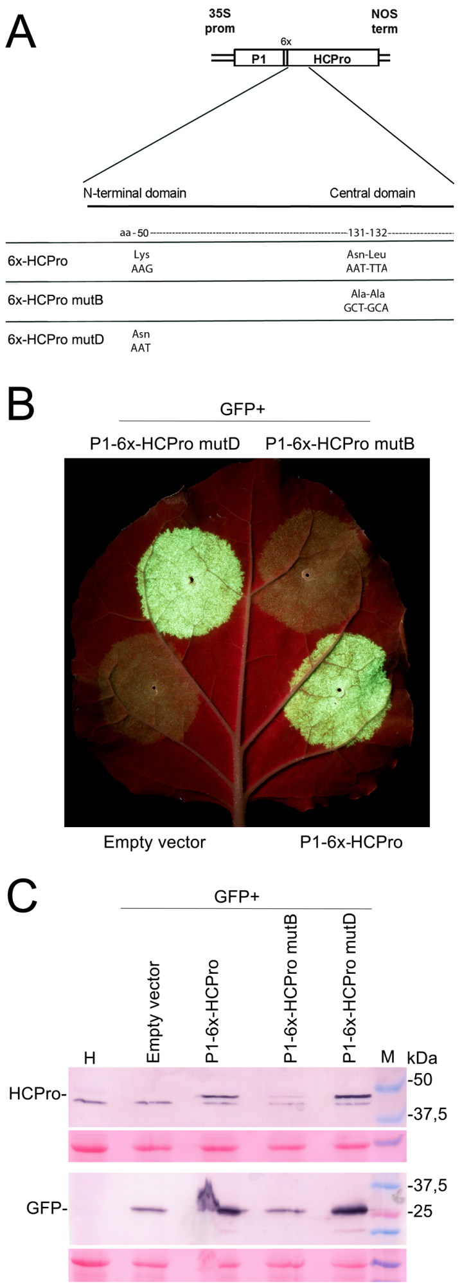
Figure 2
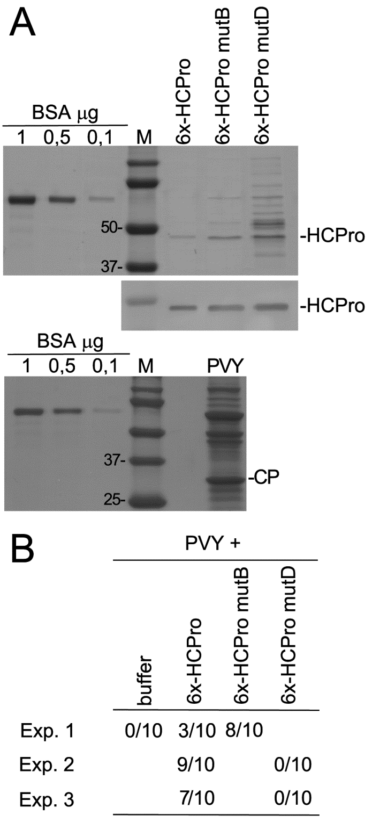

Figure 3
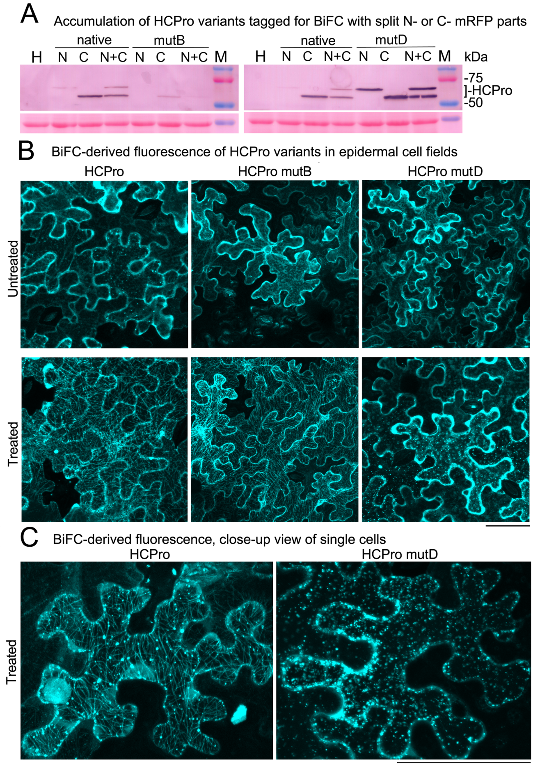

Figure 4
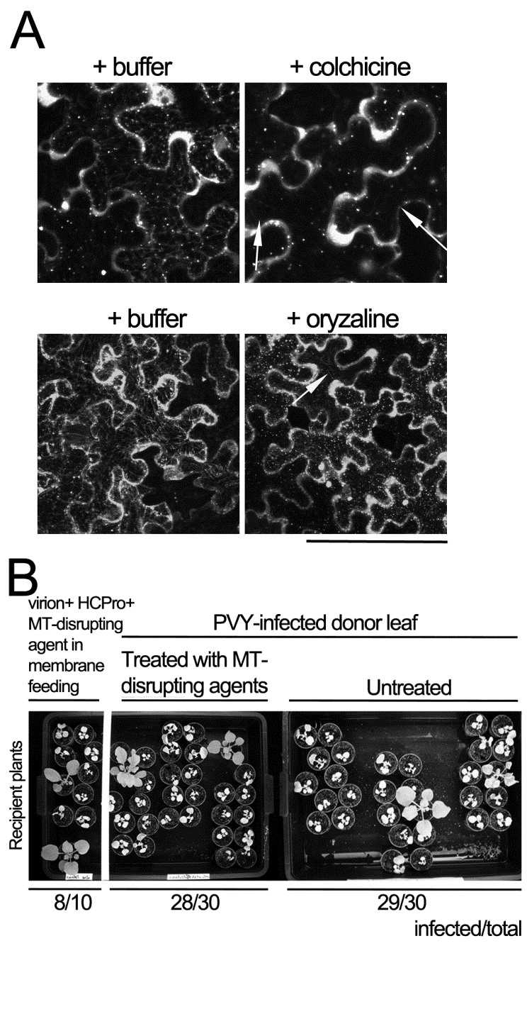

Table 1
Summary of the properties of HCPro variants used in this work
 | 6x-HCPro | 6x-HCPro mutB | 6x-HCPro mutD
Suppression of silencing activity* | Yes | No | Yes
Mediation of virus transmission by aphids** | Yes | Yes | No
Ability to coat the microtubule cytoskeleton*** | Yes | Yes | No

*: Suppresion of the partial silencing of a transiently expressed GFP reporter in Nicotiana benthamiana leaves (agropatch assay)
**: Transmission by aphids (Myzus persicae) to N. benthamiana plantlets after their feeding on purified virion and HCPro solutions (membrane feeding assays)
***: Visualization of the fluorescence distribution in stressed N. benthamiana epidermal cells of tagged HCPro dimers (BiFC)

Table 2
Number of potentially present and actually observed 21 nt sRNAs from N. benthamiana plants with sequence similarity or complementarity to the PVY genome
 | Nicotiana benthamiana | With 0 mismatches | With 1 mismatch | With 2 mismatches
Predicted in silico | Genome | 33 | 954 | 6997
Predicted in silico | Transcriptome | 3 | 61 | 1452
Actually observed | NGS* | 0 | 0 | 0

*:Next Generation Sequencing

REFERENCES
Ammar E.D., Järlfors U., Pirone T.P., 1994. Association of potyvirus helper component protein with virions and the cuticle lining the maxillary food canal and foregut of an aphid vector. Phytopathology 84, 1054-1060.
Anandalkhshmi R., Prus G.J., GE X., Marathe R., Mallory A.C., Smith T.H., Vance V.B., 1998. A viral suppressor of gene silencing in plants. Proc Natl Acad Sci USA. 95, 13079–13084.
Atreya C.D., Atreya P.L., Pirone T.P., 1990. A strategy for rapid identification and selection of site-directed low-frequency point mutations. BioTechniques 9, 702-703.
Atreya C.D., Atreya P.L., Pirone T.P., 1991. Amino acid substitutions in the coat protein result in loss of insect transmissibility of a plant virus. Proc Natl Acad Sci USA. 88, 7887-7891.
Atreya C.D., Atreya P.L., Thornbury D.W., Pirone T.P., 1992. Site- Directed Mutations in the Potyvirus HC-PRO Gene Affect Helper Component Activity, Virus Accumulation, and Symptom Expression in Infected Tobacco Plants. Virology 191, 106-111.
Atreya P.L., López-Moya J.J., Atreya C.D., Pirone T.P., 1995. Mutational analysis of the coat protein N-terminal amino acids involved in potyvirus transmission by aphids. J Gen Virol. 76, 265–270.
Bak A., Irons S.L., Martinière A., Blanc S., Drucker M., 2012. Host cell processes to accomplish mechanical and non-circulative virus transmission. Protoplasma 249, 529–539.ç
Barker H., McGeachy K. D., Toplak N., Gruden K., Žel J., Browning I., 2009. Comparison of Genome Sequence of PVY Isolates with Biological Properties. Am J Pot Res. 86, 227–238.
Baulcombe D.C., Lloyd J., Manoussopoulos I.N., Roberts I.M., Harrison B.D., 1993. Signal for potyvirus-dependent aphid transmission of potato aucuba mosaic virus and the effect of its transfer to potato virus X. J Gen Virol. 74, 1245–1253.
Blanc S., López-Moya J.J., Wang R.Y., García-Lampasona S., Thornbury D.W., Pirone T.P., 1998. A specifc interaction between coat protein and helper component correlates with aphid transmission of a potyvirus. Virology 231, 141-147.
Canto T., Ellis J.P., Bowler G., López-Abella D., 1995. Production of monoclonal antibodies to Potato virus Y Helper Component protease and their use for strain differentiation. Plant Dis. 79, 234-237.
Canto T., López-Moya J.J., López-Abella D., Serra-Yoldi M.T., Díaz-Ruíz J.R., 1995. Different helper component mutations associated with lack of aphid transmissibility in two isolates of potato virus Y. Phytopathology 85, 1519-1524.
Canto T., Cillo F., Palukaitis P., 2002. Generation of siRNAs by T-DNA sequences does not require active transcription nor homology to sequences in the plant. Mol Plant-Microbe Interact. 15, 1137-1146.
Carrington J.C., Cary S.M., Dougherty W.G., 1988. Mutational analysis of tobacco etch virus polyprotein processing: cis and trans proteolytic activity of polyproteins containing the 49.kilodalton proteinase. J Virol. 62, 2313-2320.
Carrington J.C., Freed D.D., Sanders T.C., 1989. Autocatalytic processing of the potyvirus helper component proteinase in Escherichia coli and in vitro. J Virol. 63, 4459–4463.
del Toro F.J., Tenllado F., Chung B-N., Canto T., 2014. A procedure for the transient expression of genes by agroinfiltration above the permissive threshold, to study temperature-sensitive processes in plant-pathogen interactions. Mol Plant Pathol. 15, 848–857.
del Toro F.J., Donaire L., Aguilar E., Chung B-N., Tenllado F., Canto T., 2017. Potato virus Y HCPro suppression of antiviral silencing in Nicotiana benthamiana plants correlates with its ability to bind in vivo to in 21- and 22-nucleotide small RNAs of viral sequence. J Virol. 91:e00367-17.
Dolja V.V., Herndon K.L., Pirone T.P., Carrington J.C., 1993. Spontaneous mutagenesis of a plant potyvirus genome after insertion of a foreign gene. J Virol. 67, 5968–5975.
Ebhart H.A., Thi E.P., Wang M-B., Unrau P.J., 2005. Extensive 3´ modification of plant small RNAs is modulated by helpercomponent-proteinase expression. Proc Natl Acad Sci USA. 102, 13398-13403.
Fernández-Calvino L., Goytia E., López-Abella D., Giner A., Urizarna M., Vilaplana Ll., López-Moya JJ., 2010. The helper-component protease transmission factor of tobacco etch potyvirus binds specifically to an aphid ribosomal protein homologous to the laminin receptor precursor. J Gen Virol. 91, 2862–2873
García J.A., Riechmann J.L., Laín, S., 1989. Proteolytic activity of the plum pox potyvirus Nla-like protein in Escherichia coIi. Virology 170, 362-369.
García-Ruíz H., Carbonell A., Hoyer J.S., Fahlgren N., Gilbert K.B., Takeda A., Giampetruzzi A., García-Ruíz M.T., McGinn M.G., Lowery N., Martinez-Baladejo M.T., Carrington J.C., 2015. Roles and programming of Arabidopsis ARGONAUTE proteins during Turnip mosaic virus infection. PLoS Pathog 11: e1004755.
Gillespie T., Boevink P., Haupt S., Roberts A.G., Toth R., Valentine T., Chapman S., Oparka K.J., 2002. Functional Analysis of a DNA-Shuffled Movement Protein Reveals That Microtubules Are Dispensable for the Cell-to-Cell Movement of Tobacco mosaic virus. Plant Cell 14, 1207–1222.
González I., Martínez Ll., Rakitina D., Lewsey M.G., Atienzo F.A., Llave C., Kalinina N., Carr J.P., Palukaitis P., Canto T., 2010. Cucumber mosaic virus 2b protein subcellular targets and interactions: their significance to its RNA silencing suppressor activity. Mol Plant-Microbe Interac 23, 294-303.
González-Jara P., Atencio F.A., Martínez-García B., Barajas D., Tenllado F., Díaz-Ruíz J.R., 2005. A single amino acid mutation in the plum pox virus helper component-proteinase gene abolishes both synergistic and RNA silencing suppression activities. Phytopathology 95, 894-901.
Govier D.A., Kassanis B., 1974. A virus-induced component of plant sap needed when aphids acquire potato virus Y from purified preparations. Virology 61, 420-426.
Govier D.A., Kassanis B., Pirone T.P., 1977. Partial purification and characterization of the potato virus Y helper component. Virology 78, 306-314.
Goytia E., Fernández-Calvino L., Martínez-García B., López-Abella D., López-Moya J.J., 2006. Production of plum pox virus HC-Pro functionally active for aphid transmission in a transient-expression system. J Gen Virol. 87, 3413–3423.
Haikonen T., Rajamaki M.L., Tian Y.P., Valkonen J.P., 2013a. Mutation of a short variable region in HCpro protein of Potato virus A affects interactions with a microtubule-associated protein and induces necrotic responses in tobacco. Mol Plant–Microbe Interact. 26, 721–733.
Haikonen M.T., Rajamaki M.L., Valkonen J., 2013b. Interaction of the Microtubule Associated Host Protein HIP2 with the Viral Helper Component Proteinase is Important in Infection with Potato Virus A. Mol Plant-Microbe Interact. 26, 734-744.
Hafrén A., Üstün S., Hochmuth A., Svenning S., Johansen T., Hofius D., 2018. Turnip Mosaic Virus Counteracts Selective Autophagy of the Viral Silencing Suppressor HCpro. Plant Physiol. 176, 649–662.
Huet H., Gal-on A., Meir E., Lecoq H., Raccah B., 1994. Mutations in the helper component protease gene of zucchini yellow mosaic virus affect its ability to mediate aphid transmissibility. J Gen Virol. 75, 1407-1414.
Ivanov K.I., Eskelin K., Bašić M., Swarnalok D., Löhmus A., Varjosalo M., Mäkinen K., 2016. Molecular insights into the function of the viral RNA silencing suppressor HCPro. Plant J. 85, 30-45.
Jamous R.M., Boonrod K., Fuellgrabe M.W., Ali-Shetayen M.S., Krczai G., Wassenegger M., 2011. The helper component-proteinase of the Zucchini yellow mosaic virus inhibits the Hua Enhancer 1 methyltransferase activity in vitro. J Gen Virol. 92, 2222-2226.
Kasschau K., Carrington J.C., 2001. Long-distance movement and replication maintenance functions correlate with silencing suppression activity of potyviral HC-Pro. Virology 285, 71-81.
Langmead B, Trapnell C, Pop M, Salzberg SL., 2009. Ultrafast and memory-efficient alignment of short DNA sequences to the human genome. Genome Biol. 10:R25. doi:10.1186/gb-2009-10-3-r25.
Llave C., Martínez B., Díaz-Ruíz J.R., López-Abella D., 1999a. Helper component mutations in nonconserved residues associated with aphid transmission efficiency of a pepper isolate of potato virus Y. Phytopathology 89, 1176–1181.
Llave C., Martínez B., Díaz-Ruíz J.R., López-Abella D. 1999b. Serological analysis and coat protein sequence determination of potato virus Y (PVY) pepper pathotypes and differentiation from other PVY strains. Eur J Plant Pathol 105, 847-857
Llave C., Martínez B., Díaz-Ruíz J.R., López-Abella D., 2002. Amino acid substitutions within the Cys-rich domain of the tobacco etch potyvirus HC-Pro result in loss of transmissibility by aphids. Arch Virol. 147, 2365–2375.
López-Moya J.J., Wang R.Y., Pirone T., 1999. Context of the coat protein DAG motif affects potyvirus transmissibility by aphids. J Gen Virol. 80, 3281–3288.
Martin B., Collar J.L., Tjallingii W.F., Fereres A., 1997. Intracellular ingestion and salivation by aphids may cause the acquisition and inoculation of non-persistently transmitted plant viruses. J Gen Virol. 78, 2701–2705.
Martiniére A., Gargani D., Uzest M., Lautredou N., Blanc S., Drucker M., 2009. A role for plant microtubules in the formation of transmission-specific inclusion bodies of Cauliflower mosaic virus. Plant J. 58, 135–146.
Martinière A., Bak A., Macia J-L., Lautredou N., Gargani D., Doumayrou J., Garzo E., Moreno A., Fereres A., Blanc S., Drucker M., 2013. A virus responds instantly to the presence of the vector on the host and forms transmission morphs. eLife 2013;2:e00183. DOI: 10.7554/eLife.00183
Moury B., Fabre F., Senoussi R., 2007. Estimation of the number of virus particles transmitted by an insect vector. Proc Natl Acad Sci USA. 104, 17891–17896.
Murphy J.F., Rhoads R.E., Hunt A.G., Shaw J.G., 1990. The VPg of tobacco etch virus RNA is the 49-kDa proteinase or the Nterminal 24-kDa part of the proteinase. Virology 178, 285–288.
Peng Y-H., Kadoury D., Gal-On A., Huet H., Wang Y., Raccah B., 1998. Mutations in the HC-Pro gene of zucchini yellow mosaic potyvirus: effects on aphid transmission and binding to purified virions. J Gen Virol 79, 897-904.
Pirone T.P., Blanc S., 1996. Helper-dependent vector transmission of plant viruses. Annu Rev Phytopathol. 34, 227–247.
Powell G., 2005. Intracellular salivation is the aphid activity associated with inoculation of non-persistently transmitted viruses. J Gen Virol. 86, 469–472.
Roudet-Tavert G., Germán-Retana S., Delaunay T., Del ecolle B., Candresse T., Le Gall O., 2002. Interaction between potyvirus helper component proteinase and capsid protein in infected plants. J Gen Virol. 83, 1765–1770.
Ruíz-Ferrer V., Boskovic J., Alfonso C., Rivas G., Llorca O., López-Abella D., López-Moya J.J., 2005. Structural analysis of tobacco etch potyvirus HC-Pro oligomers involved in aphid transmission. J Virol. 79, 3758–3765.
Seemanpillai M., Elamawi R., Ritzenthaler C., Heinlein M., 2006. Challenging the Role of Microtubules in Tobacco Mosaic Virus Movement by Drug Treatments Is Disputable. J Virol. 80, 6712–6715
Seo J.K., Sohn S.H., Kim K.H., 2010. A single amino acid change in HC-Pro of soybean mosaic virus alters symptom expression in a soybean cultivar carrying Rsv1 and Rsv3. Arch Virol. 156, 135–141.
Shiboleth Y.M., Haronsky E., Leibman D., Arazi T., Wassenegger M., Whitham S.A., Gaba V., Gal-On A., 2007. The conserved FRNK box in HC-Pro, a plant viral suppressor of gene silencing, is required for small RNA binding and mediates symptom development. J Virol. 81, 13135-13148.
Tena Fernández F., González I., Doblas P., Rodríguez C., Sahana N., Kaur H., Tenllado F., Praveen S., Canto T., 2013. The influence of cis -acting P1 protein and translational elements on the expression of Potato virus Y helper-component proteinase (HCPro) in heterologous systems and its suppression of silencing activity. Mol Plant Pathol. 14, 530-541.
Thornbury D.W., Hellmann G.M., Rhoads R.E., Pirone T.P., 1985. Purification and characterization of potyvirus helper component. Virology 144, 260-267.
Torrance L., Andreev I.A., Gabrenaite-Verhovskaya R., Cowan G., Mäkinen K., Taliansky M.E., 2006. An Unusual Structure at One End of Potato Potyvirus Particles. J Mol Biol. 357, 1–8.
Urcuqui-Inchima S., Maia I.G., Drugeon G., Haenni A.L., Bernardi F., 1999. Effect of mutations within the Cys-rich region of potyvirus helper component-proteinase on self-interaction. J Gen Virol. 80, 2809-2812.
Uzest M., Gargani D., Drucker M., Hebrard E., Garzo E., Candresse T., Fereres A., Blanc S., 2007. A protein key to plant virus transmission at the tip of the insect vector stylet. Proc Natl Acad Sci USA. 104, 17959–17964.
Uzest M., Gargani D., Dombrovsky A., Cazevieille C., Cot D., Blanc S., 2010. The ‘‘acrostyle’’: a newly described anatomical structure in aphid stylets. Arthropod Struct Dev. 39, 221–229.
Valli A., Gallo A., Rodamilans B., López-Moya J.J., García J.A., 2017. The HCPro from the Potyviridae family: an enviable multitasking Helper Component that every virus would like to have. Mol Plant Pathol. DOI: 10.1111/mpp.12553.
Will T., Tjallingii W.F., Thönnessen A., van Bel A.J.B., 2007. Molecular sabotage of plant defense by aphid saliva. Proc Natl Acad Sci USA.104, 10536–10541.

