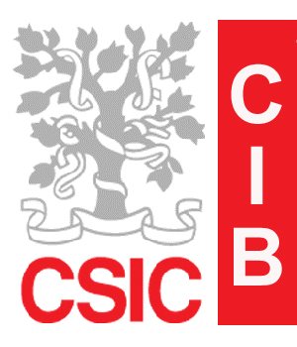
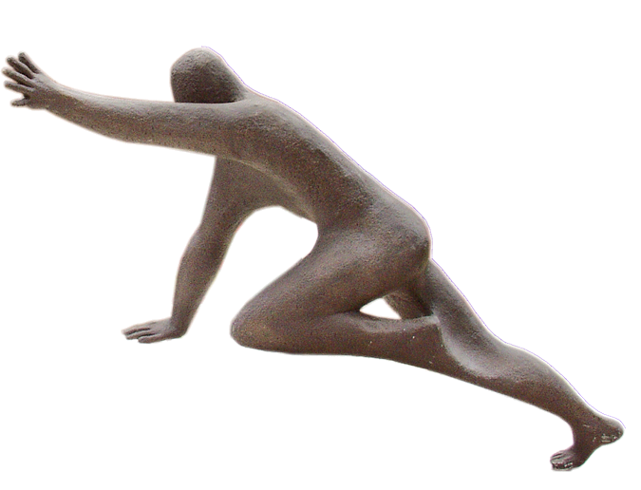

CIB-2009
SEMINAR PROGRAM

“Marie Curie Actions: Funding opportunities for researches”

Dr. David Pina
Scientific Officer
Comisión Europea

Viernes, 6 de marzo de 2009.
SALÓN DE ACTOS, 11:30 h.

www.cib.csic.es | CIB contact: Prof. Victor Muñoz  Tfno.: +34 91 837 3112 x4389
secretary: Matoya Lafita | Ramiro de Maeztu 9
matoya@cib.csic.es,  Tfno.: +34 91 837 3112 x4268 | 28040 Madrid
Metro. Metropolitano.

Linea 6, Parking

